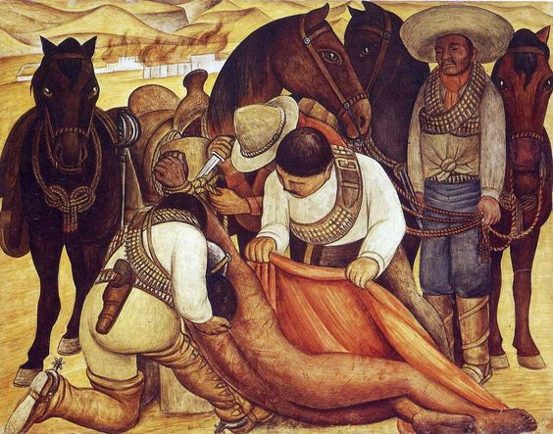
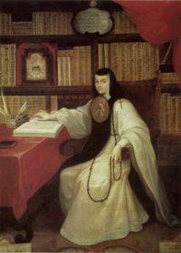

CONFERENCE ON LATIN AMERICAN HISTORY
Fall 2017 Newsletter
Volume 53, Number 2

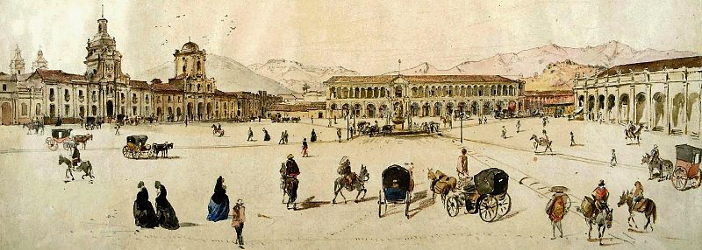

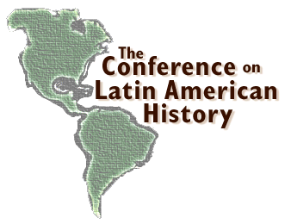
CONFERENCE ON LATIN AMERICAN HISTORY
FALL 2017 NEWSLETTER
Volume 53, Number 2

IN THIS ISSUE:

I. Message from President Lara Putnam 4
II. Message from Co-Executive Secretary Jürgen Buchenau 5
III. Message from Co-Executive Secretary Erika Edwards 6
IV. Professor Eric Von Young, Winner 2017 CLAH Distinguished Service Award 7
V. Scobie Award Reports:
1. Jorge Delgadillo 10
2.Clarissa Ibarra 11
3. Diego Luis 12
4. Mira Kohl 13
5. Gonzalo Romero Sommer 14
VI. In Appreciation: CLAH Endowment and Fund Contributors 15
VII. Welcome to Lifetime Membership Status 15
VIII. In Memoriam: Emília Viotti da Costa 16

2017 CLAH OFFICERS AND COMMITTEES

General Committee

Executive Committee:
President: Lara Putnam
Vice President: Bianca Premo
Past President: Jerry Dávila
Co-Executive Secretaries: Jürgen Buchenau and Erika Edwards

Elected Members:
Peter Guardino (2016-2017)
Barbara Weinstein (2016-2017)
Lillian Guerra (2017-2018)
Matthew O’Hara (2017-2018)
Ex-Officio Members:
HAHR Editors:
Martha Few
Zachary Morgan
Matthew Restall
Amana Solari
The Americas Editor:
Ben Vinson III
H-LatAm Editor:
John F. Schwaller

Standing Committees:

Program Committee:
Erika Edwards, Chair
Monica Rankin (2018 Chair)
Roger Kittleson

Nominating Committee:
Manuel Barcia, Chair
Gillian McGillivray
Anne Macpherson
Regional/Topical Committees

Andean Studies:
Tamara Walker, Chair
Gabriela Ramos, Secretary

Atlantic World Studies:
David Wheat, Chair
Fabricio Prado, Secretary

Borderlands/Frontiers:
Sam Truett, Chair
Sonia Hernández, Secretary

Brazilian Studies:
Celso Castilho, Chair
M. Kittiya Lee, Secretary

Caribbean Studies:
Nicole Maskiell, Chair
Glenn Chambers, Secretary

Central American Studies:
Julie Gibbings, Chair
Heather Vrana, Secretary

Chile-Río de la Plata Studies:
Erika Edwards, Chair
Jennifer Adair, Secretary

Colonial Studies:
José Carlos de la Puente, Chair
Ryan Amir Kashanipour, Secretary

Gran Colombia Studies:
Sharika Crawford, Chair
Catalina Muñoz, Secretary

Mexican Studies:
Mark Lentz, Chair
Dana Velasco Murillo, Secretary

Teaching and Teaching Materials:
Elena Albarrán, Chair
Amanda López, Secretary
I. MESSAGE FROM PRESIDENT LARA PUTNAM

November 2017

Dear friends,

As you read this, we are a short month away from our January 2018 Annual Meeting, looking forward to three days of compelling panels, vigorous roundtables, dinner reunions, and fortuitous corridor encounters. The CLAH luncheon again to offers us a chance to honor stellar achievement at each stage of the scholarly arc, from preliminary dissertation research grants to prizes supporting dissertation revisions, book prizes across multiple regional and topical foci, and our lifetime achievement award. And once again our CLAH cocktail party promises free-flowing joy and connection, as we strengthen the personal ties that undergird scholarly community. We like each other, and it shows.
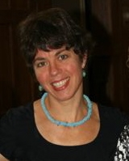
And we have so much to learn from each other. Knowledge forged through our research labors covers areas of enormous cotemporary resonance: border crossings and their consequences, structures of racism and struggles for racial justice, authoritarianism and populism. CLAH members include many who are stepping into public discussion through innovative means, sharing expertise and amplifying perspectives without simply preaching to the choir. There are inspiring and exciting exemplars among us.

The occasion of the annual meeting—and the start of a new calendar year, a new graduate admissions season, and a new semester—can also push us to reflect on collective challenges and shifts, asking whether we have been appropriately responsive. Across the American Historical Association there is increasing recognition of the significant proportion of doctoral recipients who will carry their expertise in a direction other than the professoriate. Are we ensuring that their voices, and the specificities of their priorities and concerns, are heard? Within academic settings, precarious employment statuses have become a systematic part of the landscape of instruction. Individually, collectively, are we responding to the patterned vulnerabilities this creates?

Finally, over the course of the upcoming Annual Meeting and beyond, take time to say thank you in person to the program committee (Erika Edwards, Monica Rankin, and Roger Kittleson) and to CLAH’s co-Executive Secretaries Jürgen Buchenau and Erika Edwards (again) and the fabulous graduate assistants who work alongside them at the University of North Carolina, Charlotte. They make CLAH what it is.

Warm greetings,
Lara
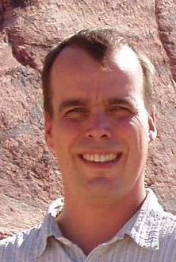
II. MESSAGE FROM CO-EXECUTIVE SECRETARY JÜRGEN BUCHENAU

Colegas:
Greetings from Charlotte!
We are looking forward to another CLAH annual meeting, the first of UNC Charlotte’s third term as host of the Secretariat. This year’s meeting will be held in conjunction with the American Historical Association meeting in Washington, D.C., January 4-7, 2018. It will feature an address by Distinguished Service Award winner Eric Van Young as well as the presentation of all of our annual awards and prizes.
As is customary for meetings in Washington, D.C., our conference is a large one. Including the sessions of the regional and thematic committees and sessions co-sponsored by the AHA, the program will include 70 sessions. Although the program is smaller than that of our last few meetings in the nation’s capital, I am sure it will be a vibrant and rewarding meeting.
This is the first newsletter that will feature a brief contribution from our new co-Executive Secretary, Dr. Erika Edwards, my colleague at UNC Charlotte and an expert in the eighteenth- and nineteenth-century history of Argentina. As most of you know, the Secretariat operates on a quinquennial schedule, and July 1, 2017 marked the beginning of a new five-year term. I am very excited about Erika’s addition to the team, and she will assume leadership in the areas of the annual meeting program, recruitment, and fundraising.
I would also like to take this opportunity to acknowledge our new graduate assistant, Lucinda Stroud, who is in charge of the everyday operations of the office, including memberships, financial issues, and the website. In addition to Lucy, another graduate assistant, Sofia Paiva, played a crucial role in the design of the annual meeting program and this newsletter. I appreciate the services of two team members who have departed: former graduate assistant Nicole Hanna, who received her M.A. in Latin American Studies last May, and former annual meeting director Marissa Nichols, who helped put together this year’s program. Marissa had help from the CLAH Program Committee chaired by Erika Edwards and also including Monica Rankin, the 2018 chair, and Roger Kittleson.
As the holidays approach, I have two requests for our membership. Please remember to renew your CLAH membership if you have not done so already, and, as appropriate, please remember the CLAH in your annual giving. Our organization, which gives out an average of $18,000 in prizes and awards each year, very much depends on the support and generosity of its members.
We look forward to seeing many of you in Washington, D.C.!
Saludos,
Jürgen

III. MESSAGE FROM CO-EXECUTIVE SECRETARY ERIKA EDWARDS

This is my first message as a co-Executive Secretary of the CLAH. Together, Jurgen and I look forward to hosting the CLAH in the years to come. I would like to take this opportunity to introduce myself. My research is about the black experience in Argentina during the eighteenth and nineteenth centuries. I have written articles about slavery and the myth of black disappearance in Argentina. My scholarship has informed my teaching interests, which include the African Diaspora, women, and the long nineteenth century.

I cannot stress enough that serving this prestigious organization is an honor. I have served as Program Committee Chair and as Chile-Río de la Plata Committee Chair. The appointment as co-Executive Secretary is the next step in my commitment to this organization. I will take on the duties of the Annual Meeting director. I want to thank the out-going Annual Director Marissa Nichols, who is currently a doctoral student at Emory University, for her service during the last two years. I look forward to working with the AHA and the new CLAH Program Committee Chair, Monica Rankin, this year.

In addition to taking on the responsibilities of the Annual Meeting director, my main goal will be to increase CLAH’s membership. As the first Black woman to serve in the CLAH leadership, which includes a succession of presidents, the Executive Secretary, and the General Committee, I am interested in bringing more diversity to the organization. My recruitment efforts will focus on graduate students, historians of color, and historians based in Latin America and the Caribbean.

Saludos,
Erika

IV. PROFESSOR ERIC VAN YOUNG, WINNER 2017 CLAH DISTINGUISHED SERVICE AWARD

A graduate of the University of Chicago (B.A. 1967) and the University of California, Berkeley (M.A. 1968; Ph.D. 1978), Professor Eric Van Young has a highly distinguished record of scholarship, teaching, and professional service. He began his teaching career at the University of Minnesota and the University of Texas, moving to the University of California, San Diego in 1982, where he has spent his career, advancing through the ranks from Assistant to Distinguished Professor of History. At UCSD he has served as Chair of the Department of History (2000-2004), Associate Director of the Center for U.S.-Mexican Studies (1997-2001), and Interim Dean of Arts and Humanities (2007-2008).

Eric’s distinctions and contributions to our profession include having served on many CLAH committees and as Vice-President and President Elect (1992-1993), as well as standing for election for President of the AHA (2005). He has held visiting professorships in Mexico (1993, 1996), Spain (1997), and France (1991), was given the Medalla 1808 by the Gobierno del Distrito Federal, México (2009), and named a Corresponding Member of the Academia Mexicana de Historia (2012). His research has been supported with Tinker (1982-1983), NEH (1986), and Guggenheim (2011-2012) fellowships. He has served on many editorial boards, including the American Historical Review, Hispanic American Historical Review, The Americas, Mexican Studies/Estudios Mexicanos, Colonial Latin American Review, as well as journals in Mexico such as Takwa, Encuentros, Vetas: Revista de El Colegio de San Luis Potosí, Historia y Grafía He played a key role in the development of the Conference of Mexican and North American Historians as a member of the Joint Organizing Committee for a decade (1985-1995), hosting the conference in 1990. Further indication of both his standing in the field and his record of professional service can be seen in the fact that a list of the dozens of institutions and presses he has consulted for on projects and manuscripts is rivaled only by a similar list of colleges and universities he has written tenure and promotion evaluations for.

The nature and impact of Eric’s voluminous research record - with a dozen books authored or edited and over one hundred articles, book chapters and published interviews to his credit - defies easy characterization. As his nominators point out, he began with a regional, agrarian study, moved on to explore political history through a cultural lens, and most recently tried his hand at biography. His first book, Hacienda and Market in Eighteenth-Century Mexico: The Rural Economy of the Guadalajara Region, 1675-1810 (1981), contributed not only to rural and Colonial historiography, but led to profound reflections on regionalism, suggesting how we can approach the subject in his co-edited volume, La ciudad y el campo en la historia de México (1992).

Van Young’s most remarkable and widely read book, The Other Rebellion: Popular Violence, Ideology, and the Mexican Struggle for Independence, 1810-1821 (2001), was awarded the Bolton-Johnson Prize in 2002. It represented a transformative moment in our understanding of the Mexican wars of Independence. As his former students put it so well, it exemplified Van Young’s “fine-grained, detailed, perfectly rendered empirical studies whose theoretical contributions emerge from evidence presented more than frameworks applied.” The volume presents peasants as something other than essentialized, one-dimensional figures, as actors with complex cultural as well as political motivations. It also reinforces the author’s longstanding view that the late colonial and early republican eras (1750-1850) are better understood as one, rather than divided by the traditional demarcation of before and after Independence.

In discussing this remarkable corpus of work, we took note of how quickly his many works have been translated and published by avid readers in the Spanish-speaking world. We also recognized that his many influential essays became part of what one letter-writer referred to as a “greatest hits” volume, Writing Mexican History (2012), certainly a rare distinction in our field. And if all of this were not enough, we eagerly await his massive biography of nineteenth-century Mexican statesman and historian Lucas Alamán, a work certain to reframe age-old debates and, if we know Eric Van Young at all, challenge our assumptions.

Eric has excelled in teaching as well, at both the undergraduate and graduate levels. He has served as doctoral thesis advisor to over two dozen students at UCSD, whose work has focused on Colonial Mexico and other nations and periods, with dissertations on topics as diverse as economic history, religion, culture, science, medicine, and popular movements. They are readily recognizable as faculty members at universities across the U.S. and abroad. What emerges most clearly from their comments is both the individual attention and support they received, and his modeling of historical research as deeply informed intellectual risk taking, with a sense of humor.

In recognition of these remarkable accomplishments, Eric Van Young is this year’s Distinguished Service Award winner.

Distinguished Service Award Committee for 2017:
Chair: Lowell Gudmundson, Mount Holyoke College
Gilbert M. Joseph, Yale University
Mary Karasch, Oakland University

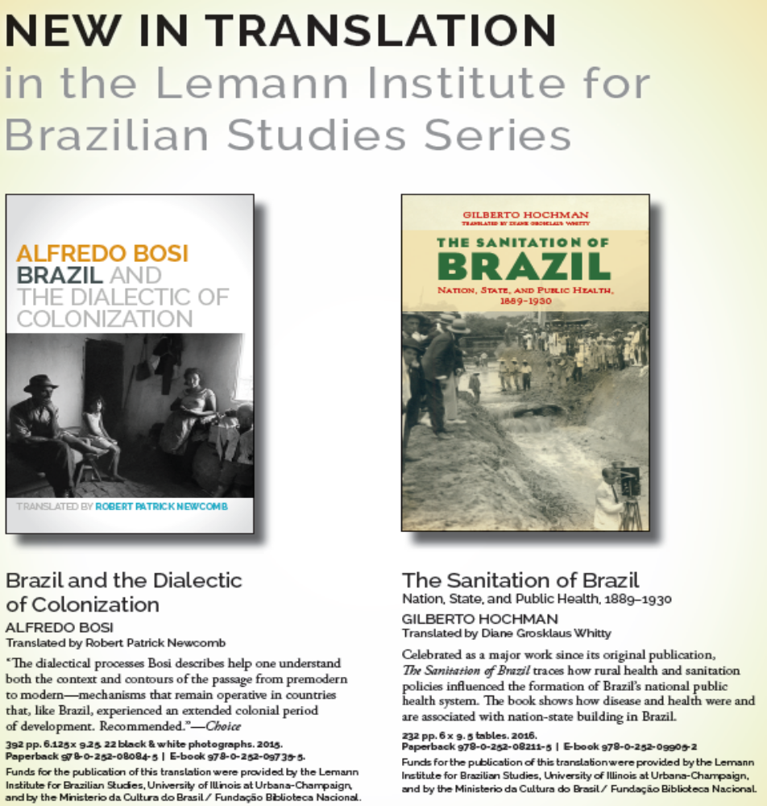
V. SCOBIE AWARD REPORTS

JORGE E. DELGADILLO
VANDERBILT UNIVERSITY
“The Shifting Notions of Race and the ‘Disappearance’ of Afrodescendants in Western Mexico, 1750-1850”

Thanks to the generous support of the James R. Scobie Award I was able to spend two months conducting pre-dissertation research in Guadalajara Mexico. I spent one month each at the Archivo de la Arquidiócesis de Guadalajara, and the Biblioteca Pública del Estado de Jalisco. During my research trip, I consulted important sources for my project, established valuable contacts with professors and archivists, and refined my dissertation prospectus, which I will present to my committee this fall.
The fact that to this day any sense of racial or ethnic collective identity remains fragmented, or weak at best, among African-descended populations in Mexico, and that Afrodescendants indeed manifested complex identities during the colonial period has sparked a debate among scholars about how this situation came to happen. However, few studies have tackled this problem directly. Two distinct positions can be distinguished in this scholarly discussion. Gonzalo Aguirre Beltrán, the pioneer of Afro-Mexican studies, asserted in his classic work that Afrodescendants had assimilated and integrated into the larger Mexican population since the late-colonial period, confounding themselves with the mestizo (mixed-race) and indigenous majority. For the most part Mexican-based studies working within the ideology of mestizaje (miscegenation), tend to explain the relative “invisibility” of Afrodescendants’ heritage in Mexico with this approach. Another set of scholars (mostly U.S.-based) contends that the post-revolutionary Mexican State erased the African heritage from the national memory by endorsing a mestizo identity that favored the Indigenous and Spanish traditions. My project, then, examines the historical origins of Mexico’s neglect of its African heritage. It analyzes the case of Guadalajara between 1750 and 1850, and traces a prolonged process of identity change in which Afrodescendants were active participants, and that was deeply intertwined with the initial stages of nation-state building. In doing so, it challenges assimilationist approaches and narratives of erasure, that either portray an idealized integration of these subjects into the wider population, or deprive them from any agency.
During the month I spent at the Biblioteca Pública del Estado de Jalisco I was able to read and take photographs of 76 court cases in which Afrodescendants from across the jurisdiction of the High Court of Guadalajara fought for their freedom, tried to block sales of relatives, or pretended a change of ownership for themselves. This information will allow me to track specific individuals and cross-list my database with extensive demographic data that is already available online or in Rodney Anderson’s Guadalajara Census Project. Also at the Biblioteca Pública, I consulted several nineteenth century newspapers in order to analyse the discourses about race, nation, slavery and the Afrodescendants’ presence or absence from such discourses. Reading the newspapers, I corroborated that indeed Afrodescendants receded to the background, but they did not disappear. In fact, when they were mentioned, they were used as a trope to speak about equality and freedom.
After finishing my research at the Biblioteca Pública, I began my enquiry at the Archivo de la Arquidiócesis. During my month there, I was able to consult part of the parish and correspondence series at the archive. In these collections, I located valuable sources about Afrodescendants’ place within society in Guadalajara and its region. For example, the series counts with several censuras eclesiásticas; documents in which a person denounces others for certain wrongdoings, so the Church could act accordingly. These censuras were mostly about fugitive slaves, whose masters denounced for running away. However, I also found a few censuras from free people of color, who denounced before the Church the robbery of their belongings. Ultimately, in these series I located important evidence of Afrodescendants’ participation in the natives’ Christianization, particularly in small towns near Guadalajara.
Together, these sources will provide my dissertation with a solid research base. I am deeply grateful to the Conference on Latin American History and the James R. Scobie Award committee for believing in my project, and providing me with valuable support as I begin my dissertation research and writing.

CLARISSA IBARRA
UNIVERSITY OF CALIFORNIA BERKELEY
"Becoming 'Professional' Socialists: the Cuban-Soviet Collaboration for Development."

The generous support of the James R. Scobie Award enabled me to spend eight weeks conducting pre-dissertation research in Havana, Cuba. During my research, I located important sources in a variety of archives, and established contacts with archivists, professors, and interviewees for the oral history aspect of my project. Furthermore, this research has allowed me to develop a stronger dissertation research agenda, which I will submit to my committee this coming spring.
My dissertation project is an investigation of the role of the Soviet Union in the development of a new, socialist Cuban science from 1959-1985. It focuses on the extent of Soviet influence in the realm of scientific research and education, and the effects of Soviet aid and education on developing Cuba’s new professional class post-Revolution. The project also seeks to examine the intricacies of Soviet and Cuban relationships in workplaces, laboratories, and universities, unraveling the social and cultural clashes that accompanied this influx of Soviet Scientists. After the mass-exodus of middle and upper class professionals in the early years of the Revolution, the remaining professionals in Cuba realized that there was a large amount of work ahead of them in order to conduct the necessary research to propel the economy forward. While Cuban professionals and scientists wanted to jump start Cuba’s research capabilities, they did not have the personnel nor the material resources to do so for at least another ten years. The solution, according to the Cuban Academy of Sciences: Cuba would simultaneously bring foreign Soviet specialists to Cuba to begin the important research for agriculture and extracting natural resources, while sending Cuban students to learn abroad in Soviet universities. This dual exchange would ensure that scientific research could continue at home, even while the Cuban specialists of the future were learning abroad. Whether within scientific institutes in Cuba or Russian universities, Soviets were deeply involved in developing the Cuban professional class post Revolution.
While Soviet specialists directed research projects, taught Cubans how to use the Soviet equipment donated to them by the USSR, conducted informational conferences and compiled many of the crucial handbooks, textbooks, and reports used in Cuban classrooms, how did Cubans interpret this privileging of Soviet knowledge in their fields? Was the experience of learning from Soviets different for Cubans studying abroad than it was for Cubans who studied in their own country? How do Cubans understand this dependency, and how was Soviet knowledge contested and adapted in their research projects, in their work, and in their studies?
In order to answer these questions, I consulted a variety of sources from multiple archives across Havana. Many of the research reports from joint Soviet-Cuban research teams were published by the Academy of Sciences, and were available at the Biblioteca Nacional José Martí. These reports offer a look at how Soviet scientists influenced the research directed by the new Academy of Sciences, whose rechristening in 1962 under the ideals of the Revolution ushered a flood of new research projects. Similarly, the Biblioteca Nacional held a collection of letters from Juan Marinello, the rector of the University of Havana, who handled the flow of petitions from Russians to work at the Universidad de La Habana. I was also able to consult letters, annual reports, and memoranda from the Academy of Sciences at the Fundación Antonio Núñez Jiménez. In addition, I located bulletins and conference transcripts from the branches of the Academy of Sciences, to determine the presence, influence, and reception of Soviet specialists within different fields. After completing my research goals, I spent the last part of my trip making important contacts with Cuban professionals who studied in the Soviet Union throughout the 1970s and 1980s. Their experiences constitute an important perspective on Soviet aid, for their experiences round out the reality of international exchange and the influence of a drastic change in the demographics of their professional and education settings. These preliminary interviews consisted of questions addressing these individuals’ experiences both within the Soviet university system and the impact their education abroad had on their career and professional opportunities.
While the preliminary sources I’ve consulted give a good glimpse at the extent of Soviet influence on Cuban science and science education, further research is necessary to untangle the intricate relationships between Cubans and Soviets in professional environments. I plan to conduct additional interviews with Cuban researchers who worked alongside Soviet scientists, Cuban professionals who learned from Russian professors, textbooks, and instructors at the workplace and at Cuban universities, as well as with Cuban students who went abroad to Soviet universities and lived and studied with Russian students and interacted with Russian professors. These interviews will unveil the cultural processes that accompanied these exchanges, and the clashes that occurred as Cuban and Soviet professionals underwent a give-and-take of information and plans for development.
Though there is much work to be done, the materials I consulted during this preliminary research trip have helped guide my research questions and my ability to design a feasible research plan for the dissertation. I am grateful to the Conference on Latin American History and the James R. Scobie committee for selecting my project and providing me with this opportunity.

DIEGO LUIS
BROWN UNIVERSITY
"Chinos in New Spain: Weapon-Toting Imperial Actors and Negotiated Social Advancement."

The Archivo General de la Nación (AGN) in Mexico City provides the treasures we ask of it. For me, it supplied over 150 documents pertaining to the first Asians in the Americas. They began arriving at the port of Acapulco in significant numbers around the turn of the seventeenth century. After disembarking, most continued traveling, eventually settling in cities, towns, and villages, all over central Mexico. They were slaves, soldiers, barbers, traders, traveling merchants, miners, millers, dock hands, sailors, healers, thieves, runaways, blasphemers, and more. They came from Japan, China, Philippines, Ternate, Malabar, Vietnam, and came in every shape, shade, and disposition.
I traveled to Mexico intending to learn more about the Asian encounter with colonial Spanish law and societal expectations but could not have anticipated the diversity of historical experiences I would find. There was an Asian slave who would take a hypnotic drug and find stolen objects, a five-year-old clairvoyant, a Japanese ambassador, a Filipino farmer trying to keep his neighbor’s cattle off his pastures, an Asian trying to build a road through his Amerindian neighbor’s crops, a slave whose master promised to free her in his will but died too soon. These stories came through secular court cases, inquisition records, license petitions, marital records, manumission cases, runaway slave notices, and financial documents.
By the grace of the baroque, bureaucratic organs of the colonial state, a glimpse into these individuals’ lives is possible. Asians intersected, clashed, and melded with Amerindians, blacks, Europeans, and those of mixed ethnicity. Like many of their peers, they strategized to achieve social advancement, learned Spanish, and crafted complex arguments to defend themselves, revealing an intimate knowledge of Spanish colonial law.
Although this research reveals a massive diversity of experience, I believe that one can distill certain consistencies across the Asian community in New Spain. They often received favor in the colonial courts—particularly the Japanese and the Filipinos from the Pampanga province—but even those with privileges, titles, and allowances, faced and complained of discrimination on the streets. Local law enforcement routinely ignored claims of favor at court and assaulted Asians in both word and deed. Those without favor essentially had no means of recourse, and slaves were similarly powerless before these offenses. These stories and cases force us to raise questions about racialization as an emergent construct in the seventeenth century and as a trans-oceanic projection and phenomenon.
The research I have conducted with the assistance of the Scobie Award will form the core of a dissertation focused on Asians as subjects of the Spanish empire—both marginalized and embraced in various spaces—and how they did and did not manage to eke out livings with colonial forces endeavoring to categorize and control them. It is a story of assimilation, of migration, of enslavement, of survival, and one that continually raises questions about early-modern racialization, about pan-Asian identity, about resistance and collaboration, and about historical lived experience. To follow up on my research at the AGN and to complete my dissertation, I anticipate future research trips to consult non-digitized sources in Sevilla and Manila, as well as to the John Carter Brown Library and the Lilly Library.

MIRA KOHL
TULANE UNIVERSITY
“Development and Cultural Nationalism in Bolivia’s Eastern Lowlands: Pan-American Fraternity on the Last Great American Frontier”

Thanks to the generosity of the James R. Scobie Award, I was able to conduct four weeks of pre-dissertation research in several archives in Bolivia. This exploratory research, coupled with a prior summer of exploratory research in Brazil, was critical in developing and gauging the feasibility of a transnational dissertation project. My dissertation, currently entitled “Pan-Latin American Fraternity on the Last Great American Frontier,” examines border politics and the little-studied efforts at Bolivian-Brazilian collaboration in frontier development from the 1930s through the 1960s. In a challenge to U.S. power in the region, Bolivia and Brazil built a railway connecting Corumbá in the Brazilian state of Mato Grosso with the Bolivian department of Santa Cruz. Likened to the U.S. Panama Canal, this railway was to be the centerpiece of an interoceanic railway that would herald a new era of national sovereignty and regional solidarity. My project analyzes why this frontier held out such promise for South-South collaboration, how the project of pan-Latin American unity collapsed, and how infrastructure construction contributed to the formation of racialized regional identities in lowland Santa Cruz. Exploratory research funded by the Scobie Award helped me identify the key archival collections and sources, as well as hone the scope, methodology, and research questions for my dissertation prospectus that I plan to defend in the early spring of 2018.
During my four week trip, I conducted research in key archives in the three cities of Santa Cruz, La Paz, and Sucre. While the majority of historical scholarship on Bolivia has focused on the Andean highlands, utilizing available sources produced and maintained in the highlands, my research will make intensive use of sources located at regional archives in the eastern lowlands. Therefore, it came as a welcome surprise that the main archive I consulted in Santa Cruz, the Archivo Histórico de la Universidad Autónoma de Gabriel René Moreno, had rich and easily accessible bibliographic, archival, and newspaper holdings. In particular, I was given access to an uncatalogued collection of reports and surveys from the Border Demarcation Commission with Brazil which proved to be a rich source of sociological data on border populations and state services during the 1940s. This collection and other sources I identified demonstrated heightened anxieties over the integration of local indigenous populations following mission secularization, a diminishing labor pool for infrastructural development projects, and increasing rates of indigenous emigration to Brazil along the newly-constructed railway corridor.
While in La Paz, I accessed Senate debates, newspapers, and ministry annual reports located at the Archivo Histórico de la Asamblea Legislativa Plurinacional. Helping place the regional within a national context, these sources shed light on the national debates over immigration and colonization while indicating the main concerns relating to border populations, infrastructure development, and regional tendencies towards separatism. I also found several reports written by the chief Bolivian railway engineer in the collections of the Casa de la Cultura Franz Tamayo. These reports offer a unique window beyond the florid language of Pan-Latin Americanism to understand the more complicated machinations of collaboration and conflict over labor and visions of development. Additionally, I had the great pleasure of making the acquaintance of the grand-nephew of the chief Bolivian railway engineer who has been nothing if not generous, offering me access to his personal collections.
My trip to the National Archive in Sucre coincided with the biannual conference of the Asociación de Estudios Bolivianos. It was a huge privilege to attend the conference, learn about the latest trends in scholarship on the region, and build contacts with national and foreign scholars alike. Of particular significance to the development of my project, one panel focused on the border between Mato Grosso and Santa Cruz with presenters primarily hailing from Brazil. These contacts will be especially useful when I continue research in Brazil in the spring of 2019. While in Sucre, I also consulted the National Archive’s impressive newspaper collection, as well as colonization documents of diverse groups including Okinawans and Mennonites. While I only scratched the surface of available sources in Sucre, I was able to identify the key collections that I will consult in future, longer-term research trips. Given the limited secondary scholarship on this borderland region, as well as on Bolivian-Brazilian collaboration, this preliminary research trip to Bolivia was enormously helpful in clarifying my key research questions, identifying areas for further inquiry, and designing a feasible research plan for the academic year of 2018-2019. Therefore, it is with immense gratitude that I thank the Conference on Latin American History and the James R. Scobie committee for the generous support that made this research trip possible.

GONZALO ROMERO SOMMER
STONY BROOK UNIVERSITY
"Alternating Currents: Electric Power and Shifting Political Power in Peru"

This past summer I was able to carry out exploratory archival research for my Ph.D. dissertation thanks to a travel grant awarded by the Conference of Latin American History. This exploratory research allowed me to determine the feasibility of my project which centers on the dynamics of state building in twentieth century Peru through the construction of electrification projects. What follows is a brief description of the sources found and their relevance to my project.
During the month of June, I visited the Archivo General de la Nación, where I intended to look at several collections. Among these were the National Fund for Economic Development as well as the Public Works Committee. Unfortunately, neither one was made available to me, as they seemed to have been misplaced (or so I was informed). However, I was far more fortunate when it came to the collection of the Ministry of Energy and Mines. I was able to look at over three dozen boxes out of a collection of over 100 uncatalogued boxes. Despite the difficulties that this entailed, I was able to find valuable information. For example, a number of boxes included documents regarding the building of the Huinco Hydroelectric Power Plant (1965), which was carried out with loans of the World Bank. These documents included feasibility reports as well as memoranda detailing how the project was advancing, as well as what challenges it met along the way. Such information is important in placing Peruvian electrification projects in a transnational perspective.
A second set of boxes included petitions from leaders of Lima’s Pueblos Jovenes (shantytowns) to obtain provisional access to energy during the Revolutionary Government of the Armed Forces (1968-1975). Of particular interest was the language used in these petitions, which sought to appeal to the political goals established by this regime. Hence petitions were made in the name of equality, solidarity with the working classes, as well as recognition of these informal settlements. Such petitions allow examining the link between electrification and mass politics, and hint towards a notion of citizenship based upon the access to certain services that were considered essential by Peruvians.
During the month of July, I carried out research at the Library of the Peruvian Congress. The information found in the debate diaries of the now defunct Chamber of Deputies spoke directly to my project. Not only did I find requests from deputies to bring electricity to their particular provinces, but also heated debates regarding the economic and political benefits of the construction of the Mantaro Hydroelectric Plant, one of the projects at the center of my research. Even more important – and much to my surprise – I found debates about modernization theory in the early sixties. These debates – and how they were linked to the expansion of electrical infrastructure – will allow me to place my project within broader debates of contemporary economic theories.
I concluded my research in August at the Biblioteca Nacional del Perú, where I looked at national newspapers from the 1930s to the 1960s. I was able to find several articles on the inauguration of different hydroelectric plants and how they were presented to the public as stepping stones towards progress and modernity. Although much remains to be remains to be researched (I will have to analyze how these projects were presented in regional newspapers, as opposed to national ones), I was able to determine that the national coverage given to these projects meant that the population at large had much interest when it came to these hydroelectric plants, especially taking into account the geographical challenges posed by their construction.
To conclude, this exploratory research trip made possible by the Scobie Award not only allowed me to determine that my project is indeed feasible, but the amount of information found and its relevance has increased my expectations regarding my dissertation’s potential and importance.

VI. IN APPRECIATION: CLAH ENDOWMENT AND FUND CONTRIBUTORS

CLAH PRIZES AND AWARDS
Robert L. Smale
Noble D. Cook
John Soluri
Reinaldo Román
Ralph Della Cava
ELINOR MELVILLE PRIZE
Audrey Fals Henderson

WARREN DEAN PRIZE
Leslie Bethell
James Woodard
Ralph Della Cava

LYDIA CABRERA AWARDS
Reinaldo Roman
Amanda Lowther

PAUL VANDERWOOD PRIZE
Bridget Chesterton
Audrey Fals Henderson

JAMES SCOBIE AWARDS
Bryan McCann
Kyle Harvey
Ralph Della Cava

MARÍA ELENA MARTÍNEZ PRIZE
Caterina Pizzigoni
Audrey Fals Henderson

LEWIS B. HANKE PRIZE
Richard Graham
Ralph Della Cava

VII. WELCOME TO LIFETIME MEMBERSHIP STATUS

Raymond CRAIB
Catherine KOMISARUK
Aaron MOULTON
Marian SCHLOTTERBECK
Max FRIEDMAD

VIII. IN MEMORIAM: EMÍLIA VIOTTI DA COSTA

Emilia Viotti da Costa died on November 2, 2017, at the age of 89 from complications following surgery. Emilia was not just a brilliant historian but a charismatic figure, a presence, someone who could walk into a room and draw everyone’s attention by the force of her intellect and personality. She left her mark on the field of Latin American history not only through her scholarly production and the many students that she trained, but also by her commanding presence in a discipline that, until recently, included few women who could command that degree of respect and recognition.

The early years of Emilia’s career could be portrayed as a series of triumphs, the academic version of a charmed life. She studied at the University of São Paulo with Sérgio Buarque de Holanda, then won a fellowship to do further study in Paris at the Sorbonne. Returning to Brazil, she published her first book, Da senzala à colônia (1966), to universal acclaim. This pioneering study of the decline of the slavocratic order in the coffee-planting zones formed part of a wave of studies of slavery and abolition in Brazil, most of them authored by sociologists who favored a structuralist approach that minimized human agency. Trained as a historian, Emilia insisted on paying attention to the interaction between ideas, economic trends, and social struggles, emphasizing contingency, social identities, and incipient class conflict. She was, for example, among the first historians to recognize the role that the slaves themselves played in the process of emancipation. The result was a study of the Brazilian coffee-growing regions in the transition from slavery to free labor that is still the starting point for anyone interested in this crucial topic.

After completing her doctorate, in 1964 Emilia joined the History Department at USP, where her youth, dynamism, and commitment to innovation made her a magnet for promising students, and led to her appointment to the cátedra in Brazilian history. In an account of this period, Emilia recalled remarking to a colleague, as they looked out a window onto the USP campus, that they had the best jobs in the world. And even though her time at USP coincided with the onset of the dictatorship in Brazil, repression during those first few years of military rule had been mild enough for even left-wing academics to imagine that they would be allowed to pursue their careers undisturbed. Invited by the students in 1968 to deliver the public lecture inaugurating the academic year, she boldly argued for university autonomy and opposed the military’s proposal for a more technocratic curriculum; this public criticism, combined with denunciations by a trio of colleagues motivated by professional jealousy or ideological zeal, led to her forced “retirement” from USP the following year. After a brief imprisonment, Emília, finding her life and career in shambles, went into exile, heading north to the U.S. as the only means to survive in light of the hard right turn of the Brazilian military regime. Suddenly she was faced with the challenge of adapting to a very different academic and linguistic environment, one where few people knew who she was, and where she had precious few contacts and resources. Fortunately, through the intercession of a young Brazilianist, Michael Hall, and the eminent economist Werner Baer, she was able to get temporary teaching posts at Tulane and the University of Illinois, and from there moved to Smith College. Although her time at the latter institution was brief, it was long enough for Emilia to meet R. Jackson Wilson, a distinguished US historian, who would become her devoted companion and intellectual partner for the next 45 years.

The decisive moment was, of course, her move to Yale, where she was hired in 1973 to replace Richard Morse, who had taken an extended leave to direct the Ford Foundation in Rio. Although Emilia had something of a love-hate relationship with the Yale History Department, it certainly defined the course of her academic career from there on in. At Yale she encountered a cohort of graduate students in Latin American history, most of whom had become interested in the region as a result of their engagement with the radical activism of the late ‘sixties and early ‘seventies and for whom Emilia—a brilliant woman exiled by a military regime—was immediately sympathetic and appealing, if a little intimidating. In retrospect, I can only imagine what a challenge it was for her, someone who at USP had been able to focus exclusively on a specific segment of Brazilian history, suddenly serving as mentor to students studying everything from colonial Peru to modern Mexico. But Emilia had the kind of self-confidence and capacious intelligence that allowed her to make that transition, and to do it without our perceiving what a strain it must have been for her, especially since, at the same time, she was trying to create a stable, reasonable life for the two children who accompanied her to the states.

The transition to Yale was not entirely smooth, in more ways than one. There was not a single tenured woman in the History Department when Emilia arrived in New Haven (in contrast to the USP department, which had a number of distinguished women historians on its faculty), and a few of the more conservative Yale professors—especially in European history—looked askance at this Brazilian woman whose work smacked of Marxism (which always weighed more in their estimation than the unmistakable influence of Max Weber or Fernand Braudel in Emilia’s scholarship). To no one’s surprise, when she came up for tenure, there was a small but significant minority in the department that registered their opposition. Only later did I fully appreciate how distressing it must have been to be subjected to such scrutiny and judgement at a point in her career when she should have been enjoying the prestige and honors appropriate to her status in the field of Brazilian history. Fortunately, with the vigorous endorsement of the stellar cohort of US historians in the department at the time, and the support of the newly-appointed provost, Emilia eventually was granted tenure, but I suspect that this experience stayed with her and helps explain her often caustic comments about academic life in the US.

Meanwhile, Emilia was putting the finishing touches on a collection of her essays published first in Portuguese as Da monarquia à república (1977) and then as The Brazilian Empire: Myths and Histories (1985). Though the essays range over a diverse set of themes, the thread running through all of them was the decisive role of slave labor and the master-slave relationship in the emergence of the Brazilian nation, and in the hierarchies and inequities that have defined so much of its postcolonial history. The Brazilian Empire has been widely adopted in courses dealing with Brazil and nineteenth-century Latin America; one sign of the book’s success is its re-issue in 2000 with an additional chapter on the image of women in imperial Brazil.

Working with Emilia could be by turns both exhilarating and exasperating. She read her students’ work with great care but never pulled punches when she didn’t like what she had read, and often had very strong opinions about how the work should be revised. Gentle criticism was not her strong suit, but we all knew that she would always take us seriously and that our work would be better for her close readings and forceful suggestions. Certainly, she never lacked for graduate students; even though for years she was the only tenured Latin Americanist at Yale, the department gained a reputation as the place to do graduate work in Latin American history.

Almost all of Emilia’s research dealt with postcolonial Brazil, but for her next book, Crowns of Glory, Tears of Blood (1994), she chose a research venue outside Brazil, focusing on the 1823 slave uprising in the British colony of Demerara. With the rich documentation of the British colonial archives at her disposal, Costa was able to weave a gripping narrative and compelling interpretation of the causes and the course of the rebellion, and the implications of its aftermath for the process of emancipation. She considered a range of factors—the shifting international context following the Haitian Revolution and the rise of abolitionism in Britain, the presence of British missionaries critical of the planter elite—but the core of her argument lay in the experience of bondage and forced labor. In other words, she sees the rebellion as emerging from within the slave community, and reflecting the slaves’ grievances, solidarities, and conceptions of leadership. As a work of historical interpretation, it is deeply impressive, but perhaps the most memorable aspect of the book is its beautiful prose. Emilia had not only written the book in English but had developed a style that would put most of her fellow historians to shame.

In 1999 Emilia (which is what we called her from day one, at her insistence) retired from Yale as emeritus professor. The previous year her former students and colleagues had organized a symposium in her honor and, true to form, Emilia refused to perform the accustomed role of passive and pleased observer, and she herself delivered the keynote address. And even after a fall on the second day –a stroke had left her somewhat unsteady on her feet—that caused a fracture in her arm, she insisted on being present for every panel.

Three years after her retirement from Yale, Emilia was publicly granted emeritus status at USP in a ceremony that highlighted her crucial contributions to Brazilian scholarship as well as the tragedy of her expulsion from the university during the dictatorship. Although her later work touched on several new themes, including an almost prophetic study of the role of Brazil’s Supreme Court in the construction of citizenship, her greatest impact can be seen in the historiography of slavery, slave resistance, and slave emancipation, and in the work of the numerous historians whom she trained, first at USP, and then at Yale. Emilia had been in very poor health in recent months, so her death was not entirely unexpected, but it is still difficult for me and the many others who worked with her over the years to grasp the fact that she is no longer alive. Of course, she’s still with us, shaping the way we think about history and the relationship of historical thinking to political problems and social injustice. She’s still looking over our shoulders, appreciating the strengths of our work, but never hesitating to point out its flaws or limitations. We all carry at least some of her historical insights with us, and I like to think that the entire field of Latin American history is more stimulating and more vibrant thanks to her presence among us.

Barbara Weinstein, New York University

The Newsletter (ISSN 0069-8466) of the Conference on Latin American History is published semi-annually (Spring/Summer and Fall/Winter) in the offices of the Secretariat, located at the University of North Carolina at Charlotte. Deadlines for submission of material for the Newsletter are March and September. Receipt of the newsletter is contingent upon membership in CLAH. For more information regarding dues and other activities of the Conference, please write to: CLAH Secretariat, Department of History, University of North Carolina at Charlotte, 9201 University City Blvd., Charlotte, NC 28223

Cover page illustrations:
Top left: Diego Rivera, La liberación del peón. 1923
Top right: Portrait of Sor Juana Ines de La Cruz. Miguel Cabrera, 1750
Bottom: La Plaza de Armas de Santiago, por Joseph Selleny. 1859. Expedición Novara. Colección Museo Histórico Nacional de Chile.

CONFERENCE ON LATIN AMERICAN HISTORY PUBLICATIONS
LOMBARDI, CATHERYN L., and John V. Lombardi, with K. Lynn Stoner. Latin American History: A Teaching Atlas. 162 pages, 136 maps. 1984. ISBN 0-299-097145 (paperback only), $17.95.

Order from: Chicago Distribution Center
11030 S. Langley Avenue
Chicago, IL 60628 1-800-621-2736

Individuals must prepay both merchandise and shipping. Current book rate shipping charges are: U. S. $3.50 and $.75 each additional book. Foreign, including Canada: $4.50 first book and $1 each additional book. Master Card and Visa are accepted. Canadian customers must include 7% GST on merchandise only.

